When suppliers send you “We are writing to inform you” letters announcing a price increase, push back by using this ingenious tactic invented by our colleague, Mike Brown. You may be pleasantly surprised by the results.
When Mike Brown was Director of Global Strategic Sourcing at Columbus McKinnon, he came up with an effective way of handling price increase form letters. He countered with his own form letter – the “anti-foo-foo letter”, as he coined it. It is an automatic pushback response that puts the onus on suppliers to justify higher prices by detailing changes to their input costs.
Documented, supportable increases are considered; the rest (aka the “foo-foo”) are rejected. Mike uses ProPurchaser to easily determine which is which.
In the first year, Mike saved more than 2% of his material costs without even negotiating. “Foo-foo” requests simply disappeared because, in a whopping 80% of cases, suppliers who sent in form letters did not (or could not) justify the requested increases.
The savings did not stop there. Mike put the time he saved to very good use: thoroughly preparing for negotiations with his highest spend suppliers – high-touch, strategic discussions that were never reduced to form letters.
Mike’s response to foo-foo letters has three parts:
1. Opening
2. Spreadsheet
3. Signoff

We encourage you to make the template your own by customizing it and then putting it to work.

Template for an Anti-Foo-Foo email
Part 1 - Opening
Re: Your recent request for a price increase for _____________________________
You recently submitted a request for a price increase for the above item(s). Please be advised that, at this time, we respectfully decline to accept this increase until you complete a table similar to the one shown below. This table is only for the key raw materials and direct labor that go into the above item(s). Please note that high accuracy is not required; the figures provided need only be best estimates. The example below serves to illustrate:

Part 2 - Spreadsheet
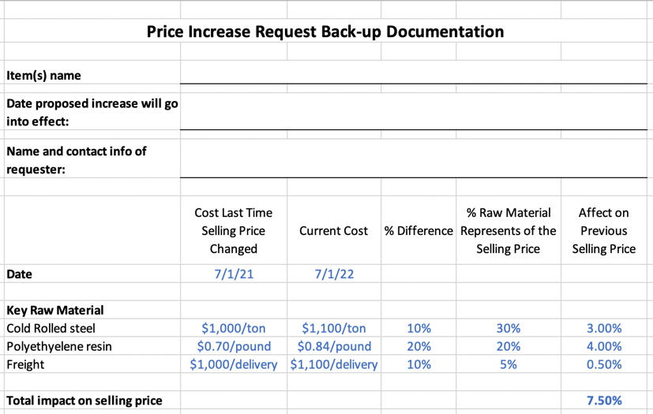

Please note: the figures in blue are examples of numbers suppliers would provide.
You will note that the example above would support a request for a 7.5% price increase. After we receive a completed table similar to the one above, we will analyze your figures, compare them to our own data, and contact you to discuss.
Save this document to your own computer and click the icon below to open a customizable spreadsheet.

Part 3 - Signoff
Please understand that while we recognize the pressure many companies feel to raise their prices, we at ABC Corp have adopted a continuous improvement strategy in order to enhance our own efficiencies and cost containment. We expect our preferred suppliers to do the same. If we do not hear from you within 20 business days, we will assume the price increase is no longer required and the matter is closed.
Thank you in advance for your cooperation in this matter. We look forward to a long and mutually beneficial relationship between our organizations.
[Insert your email signature here.]

Following Up is Easy
When you receive a completed table from a supplier, verify their raw material cost changes using your own independent source of information [like ProPurchaser].
To help set up your own anti-foo-foo campaign, you are invited to sign up for a free ProPurchaser trial membership (no credit card required).
And remember, there are many more negotiating tips in the ProPurchaser Best Practices library.

